Name ______________________________ AP Calculus
Chapter 6 Review
Show all your work!

1. $\int{x^{3}+4x−2}$ dx =

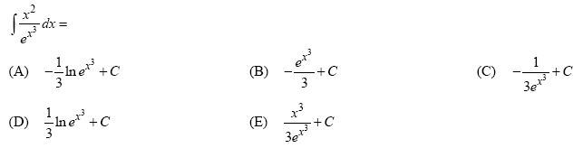
2.

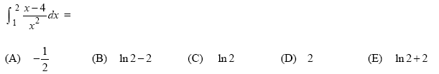
3.

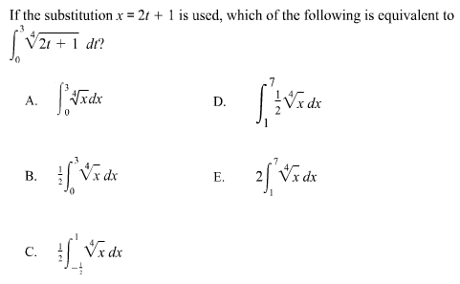
4.

5.
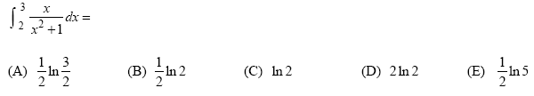

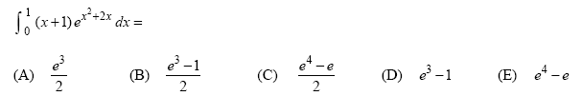
6.

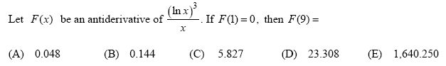
7.

8.

9.
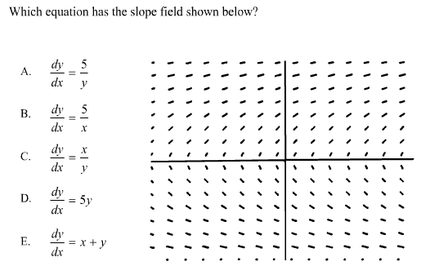

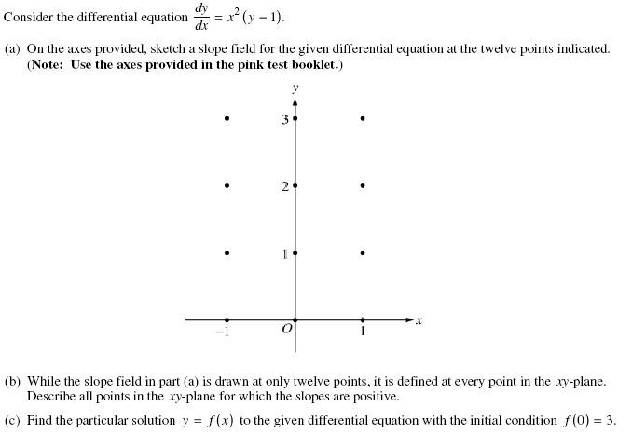
10.

